Welcome!
Date
Name
Spouse
Address
City
State Zip _________
Email

Please Contact By
Card Phone Visit

Telephone Best Time to Call
Home ______________
Work ______________

Guest: First Time Second Time
Are you a church member: yes no
Church
City, State

Circle Appropriate Age/Grade Group(s)
Preschool: Ages: B-1 2-3 4-5
Children: Grades: K 1 2 3 4 5 6
Youth: Grades: 7 8 9 10 11 12
Adults: Ages:18-29 30s 40s 50s 60s+

How did you learn about our church?
Newspaper Friend Yellow Pages Mail
Other

I am a guest of:

New in the Community? Yes No
Names & ages of children at home

Weekly Service & Activity Schedule

September 21, 2014
9:45 a.m. Sunday School
11:00 a.m. Morning Worship Service
6:00 p.m. Town Hall Meeting w/ Pastor Search Comm.

Week of September 21
Wednesday, 7:00 p.m. Youth Activities
Wednesday, 7:00 p.m. Adult Prayer & Bible Study

Upcoming Events
September
1-30…………………….........……. Mary Hill Davis Offering
24…………………………………………..See You at the Pole
25……………………………………….…….Adult Fellowship
Birthday & Anniversary Recognitions will occur on the final Sunday of each month.

Global Week of Student Prayer
Sept 21 – Sept 27

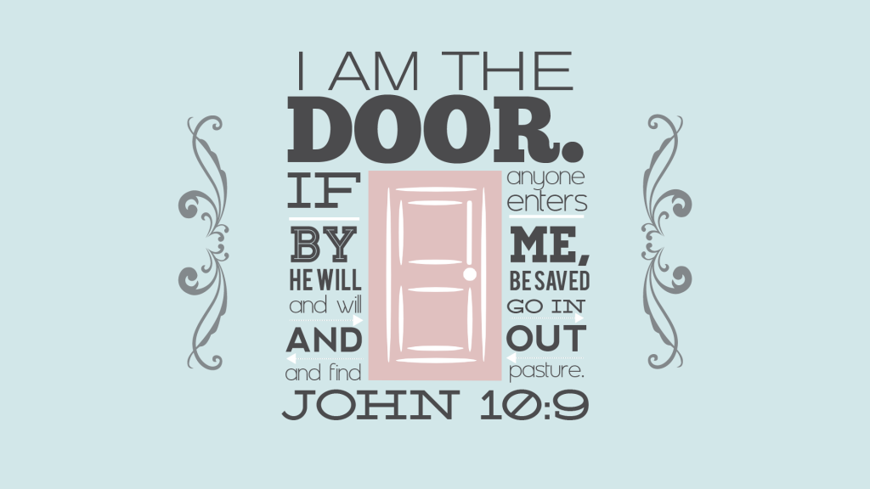

Knobbs Springs Baptist Church

Welcome Bro. Ryan Carpenter

September 21, 2014

Church Information:

KnobbsSpringsBC.com KnobbsSpringsBaptist@gmail.com
1662 CR 305, McDade, Texas 78650 512-273-2743
Patti Radford, Office Manager 512-968-7821

